NAME:P HARISH
Reg no:192524197

2:Develop a lexical Analyzer to identify whether a given line is a comment or not using C

PROGRAM:
#include <stdio.h>
#include <string.h>

int main()
{
char com[100];
int i = 2, a = 0;

printf("\nEnter comment: ");
fgets(com, sizeof(com), stdin);

if (com[0] == '/')
{
if (com[1] == '/')
{
printf("\nIt is a comment");
}
else if (com[1] == '*')
{
for (i = 2; i < strlen(com); i++)
{
if (com[i] == '*' && com[i + 1] == '/')
{
printf("\nIt is a comment");
a = 1;
break;
}
}

if (a == 0)
{
printf("\nIt is not a comment");
}
}
else
{
printf("\nIt is not a comment");
}
}
else
{
printf("\nIt is not a comment");
}

return 0;
}

Output:

Sample Output 1
Enter comment: // This is a comment

It is a comment

Sample Output 2
Enter comment: /* This is a comment */

It is a comment

Sample Output 3
Enter comment: / This is not a comment

It is not a comment

Program Screenshot:

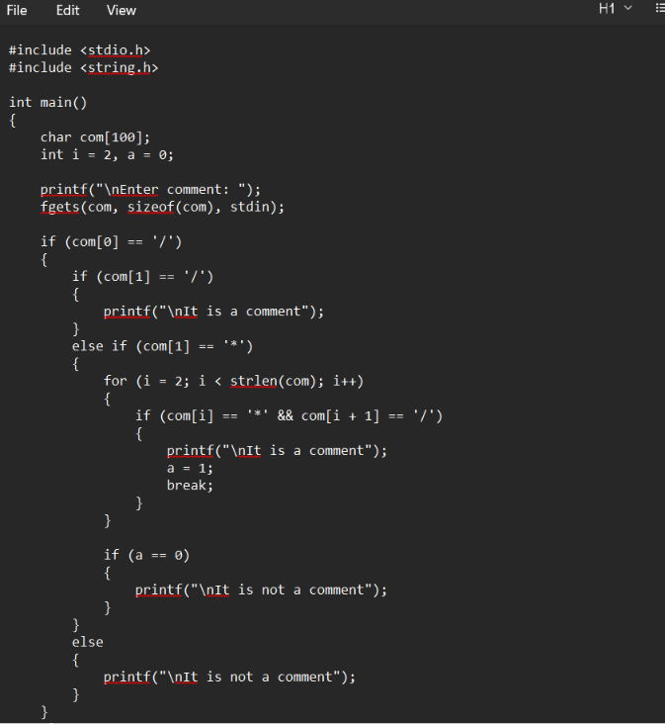
OUTPUT:
